C-Power 2&3 series wifi card operation manual

一、The WiFi control card sends the program
WiFi control cards have 2 ways of sending programs, one is using a mobile phone to send a program, and two is using a computer software called led-center-m to send programs .

1、Mobile phone send programs, see mobile phone app using documents.

2、The computer sends programs as follows ：
The default factory parameters for our WiFi control card are as follows：
pattern：AP pattern
IP address：192.168.1.222
gateway ：192.168.1.1
subnet mask：255.255.255.0
port：5200
SSID：lumenchina-xx (xx Represents the MAC address after two bits )
Password: None
(1) first of all, the computer is connected wirelessly to the WIFI control card. Our control card defaults to the AP mode, so we can find a corresponding WIFI.
Figure: WIFI. to connect to SSID for lumenchina-C5
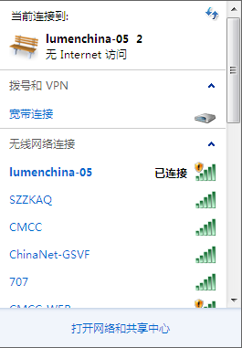

(2)manually set the IP of the computer, or it can be automatically acquired. (when the control card is STA mode, it must be manually obtained)

The IP of the computer should not be the same as the IP of the control card in the same network segment. The subnet mask and gateway should be consistent with the control card.
.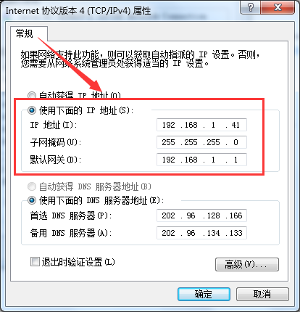
（3）(3) when setup is complete,
You find Tools → find device → search network find control card .
（4）open setting → advance →define LED screen →Set the correct parameters..

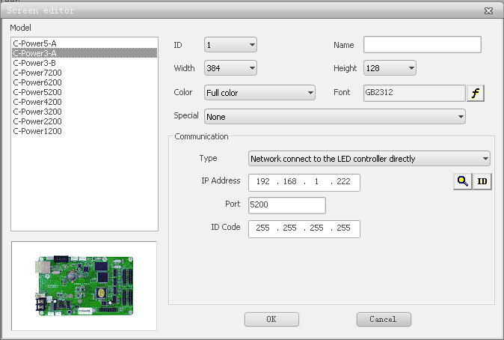

(5) after the parameters are set correctly, you can edit the program and click the button in the red area in the picture below to send the program
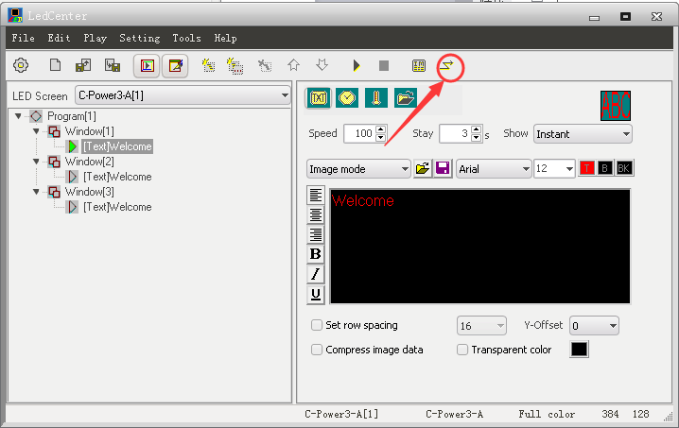

二、The serial port modifies the parameters of the WiFi control card
1、Open the "led control center" software

2、Modify current disk parameters
（1）After entering the software ，click“Tools”→“Ledtool”→“C-Power50”entering configure.

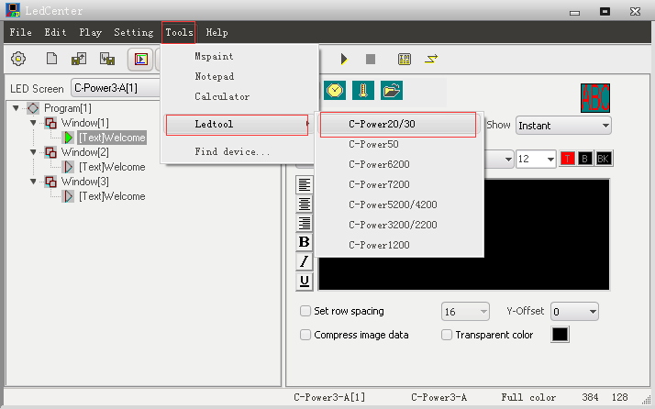

（2）Enter the software settings, select WIFI options. The control card is connected with the COM1 port, first click "connect WIFI module". After success, click "enter WIFI module", suggesting that after the success, click the "read back" after the success, and finally click "password".
Note: when the "WIFI module" fails, restart the control card and repeat the above operation
Password: 26888

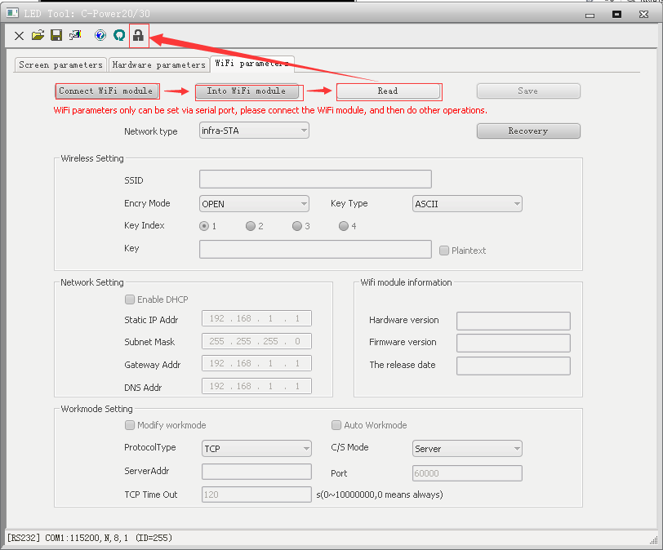
You can modify the parameters of WIFI when you complete the previous operations as shown in the figure above.

（3）When you have finished, remember to click "save". The following dialog box will appear, click OK, and then restart the control card.

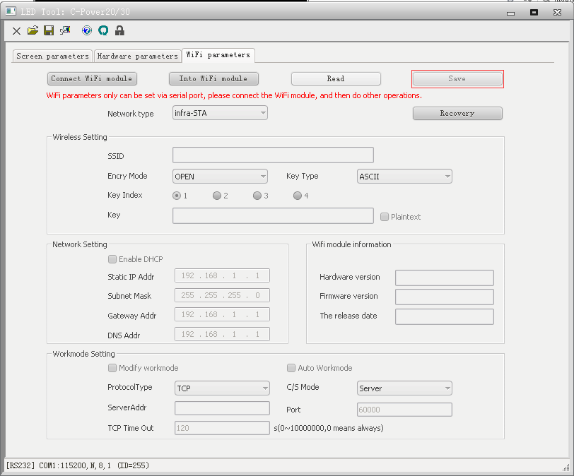

三、Web page modify WIFI control card parameters

1.Connect WIFI
Lumen WIFI card factory defaults to AP mode, using a computer to connect WIFI.

2.Modify current disk parameters
When the computer connects to the wireless signal of the WIFI control card, open the browser and enter 192.168.1.222 to enter the WIFI parameter setting interface.

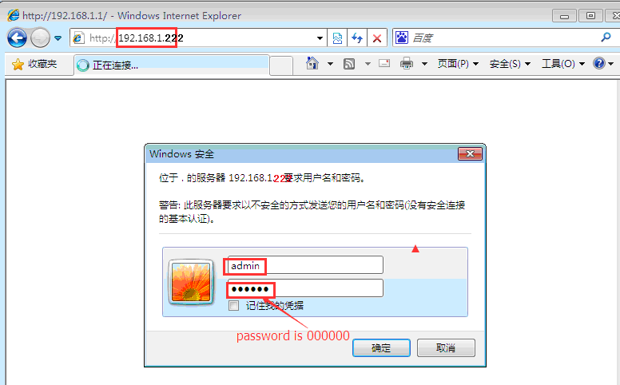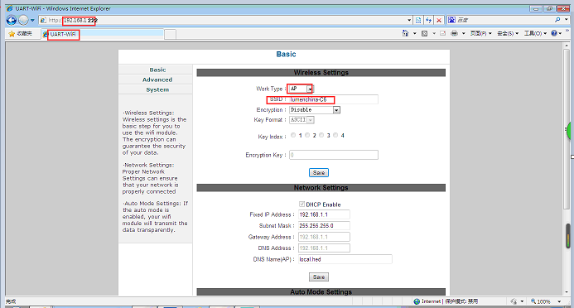

(1) modify the SSID and password, after the completion of the modification, you need to restart the control card.

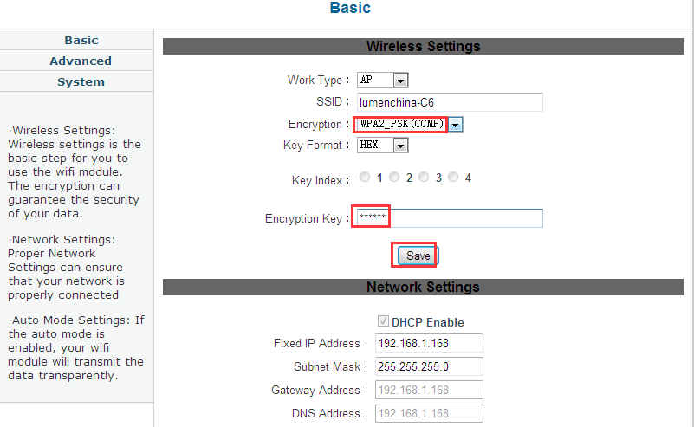

(2) modify the IP of the control card and restart the control card after modification

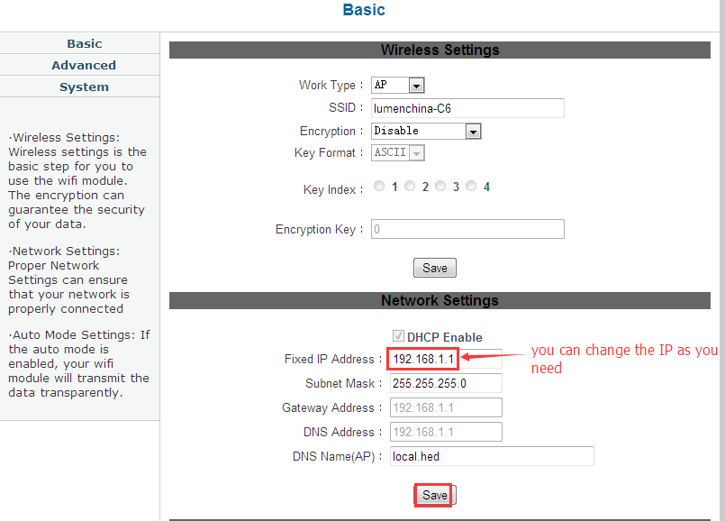

（3）modify the router mode, and when you want to connect the control card to the router, you need to modify the router's mode,
Change from AP mode to STA mode. You need to restart the control card after the changes have been completed.

